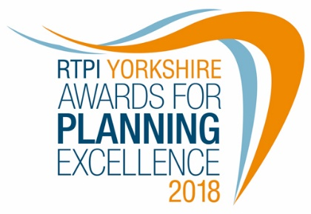
RTPI Yorkshire for Planning Excellence 2018
Entry Form
- Tip: read the criteria and eligibility set out in our separate guidance note
- The RTPI Yorkshire Awards are FREE to enter
Please read our privacy statement before completing this form.
Name of project:

Details for main contact handling awards correspondence

Name of main contact:

Contact email address:

Contact number: Mobile:

Job title:

RTPI Membership number (if applicable)

Media/PR Contact details
Contact details for PR/Media (if different from main contact):

Social Media Accounts, such as Twitter (if relevant):

Entry information

☐Main Award

Name of organisation:

Organisation postal address:

Location of scheme/proposal/project including postcode (where possible):

List of other organisations/individuals involved (up to ten key individuals with employer, job title and RTPI membership details where applicable):

What is the scheme/proposal/project (maximum 25 words):

Description of submitted scheme/proposal/project (for marketing purposes, maximum 100 words):

Reminder about how to enter the RTPI Yorkshire Awards:

Entries are free and should be submitted to yorkshire@rtpi.org.uk

Submissions should include:

☐This completed entry summary sheet
☐ Full submission document addressing the criteria - no more than 4 A4 sides*
☐Up to 5 individual jpg images (min 300 dpi, captioned and credited)

You may wish to submit by Wetransfer.com or Dropbox.

SPECIAL NOTE: New for 2018:
The overall winner of the RTPI Yorkshire will be automatically shortlisted into the relevant category at the national RTPI Awards of Excellence in 2019. If you do not wish this to happen please tick this box. ☐

[*NB: overall winners shortlisted will be able to supplement their submission document in line with the standard entry requirements for the national Awards].
I have read and agree to the RTPI’s terms and conditions and privacy statement ☐

Closing date for entries: Monday 23 July 2018

