How to request a new password for the CIfA website
- Go to our website http://www.archaeologists.net/ and click on ‘Request New Password’

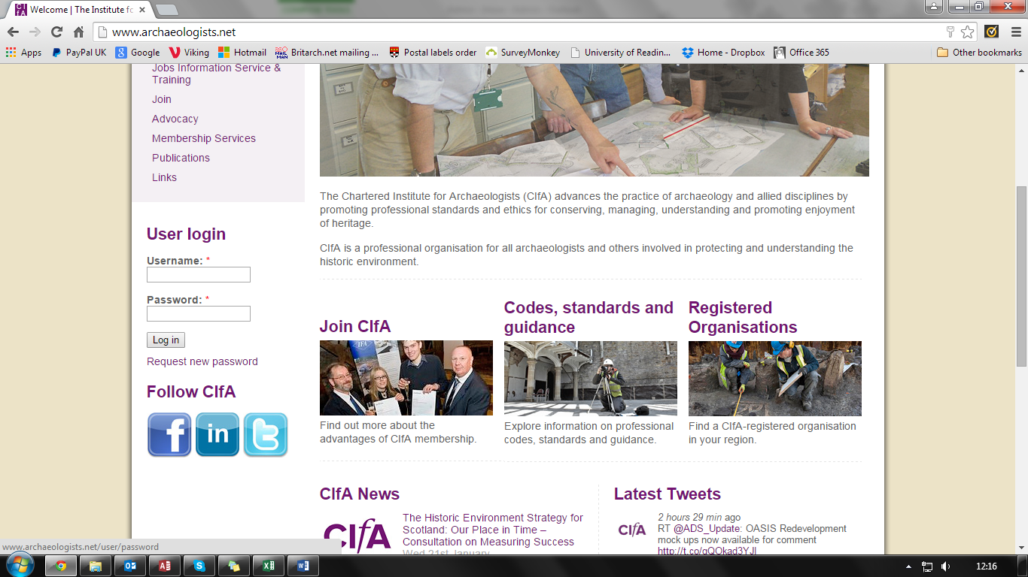

- Enter your username or email address (your username will be your name in lower case with a space between your first and second name i.e. ‘joe bloggs’)
- Then click on ‘Email new password’.
- You should then receive an email with instructions on how to create your new password.

