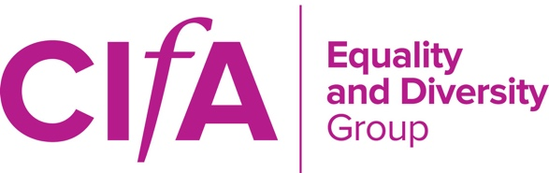
THE CHARTERED INSTITUTE FOR ARCHAEOLOGISTS
EQUALITY AND DIVERSITY GROUP

TREASURER REPORT – March 2018 AGM

Monday 5th March 2018, 10.30-13.00
AGM

~~~

Annual Budget Request form for the period April 2018 – end March 2019 was submitted in January 2018. Requested £800 to cover committee travel, group forms, other travel expenses (i.e. attendance at conferences/events that represent group interest) and the AGM (i.e. travel/venue expenses).
Outcome: TBC.
~~~

Financial overview for April 2017 – March 2018
- E&D Budget for this financial year (2017/2018) was £725 (original request £800).
- Current spending: £264.67
- Remaining budget: £460.33
Date | Ref. | Details | Value | Remaining budget
24/04/2017 | E. Plunkett | Display board & stationary for E&D ground stand at CIfA Conference 2017 | £10.79 | £714.21
08/07/2017 | C. Poucher | Off-peak Travel card Return (with disabled rail card) to London from Oxford (London Pride) | £19.80 | £694.41
08/17/2017 | C. Poucher | T Shirt – via Vista Print (custom made) (T-shirt for London Pride) | £9.58 | £684.83
08/17/17 | E. Plunkett | Travel – Bus from Oxford to London (For 1; London pride) | £18.00 | £666.83
08/17/17 | E. Plunkett | Parking at Oxford (London pride) | £4.00 | £662.83
08/17/17 | E. Plunkett | T-shirts with group/museums logo x2 (London Pride) | £21.55 | £641.28
11/10/2017 | S. Foxley | Travel to October mtg 2017 | £24.00 | £617.28
04/12/2017 | H. Cobb | Travel to October mtg 2017 | £156.95 | £460.33

