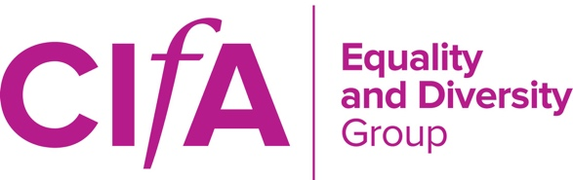
CHARTERED INSTITUTE FOR ARCHAEOLOGISTS
EQUALITY AND DIVERSITY GROUP

AGENDA – ANNUAL GENERAL MEETING 2018

Monday 5th March 2017, 1030 – 1300
Historic England, Cannon Bridge House, 25 Dowgate Hill, London, EC4R 2YA

(Tea and coffee will be available from 1030; the meeting will formally commence at 1100, and will conclude no later than 1300)

---

Teleconference details
Please be in a quiet location and have good reception if on mobile phone. Participants should phone 0800 3589 490 (freephone), and then when instructed enter Participant PIN 50074253

---

- Apologies for absence and confirmation of quoracy

- Approval of the minutes of the 2017 AGM [Attachment]

- Chair’s Report
  - Yearly focus
  - Current committee

- Secretary’s Report

- Treasurer’s Report [Attachment]

- Comms Report

- Activities/CPD Update
  - CIfA Conference 2018
  - Training event

- Election of new committee members

- Any other business

- Date of next meeting

