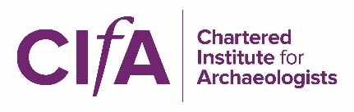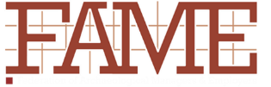

Bullying, harassment and discrimination: a joint statement by CIfA, FAME and the Prospect Archaeologists’ Branch

We acknowledge that the problems of bullying, harassment and discrimination which exist in society are also present in our profession and that addressing them requires a change of culture. We recognise that, as well as causing significant harm to individuals, failure to address these issues leads to the loss of talented professionals from the sector and hampers our ability to recruit the archaeologists of the future.

We acknowledge that many organisations have policies and procedures in place in relation to equal opportunities and to bullying and/or harassment but recognise that further training and support may be needed to ensure that they are effective.

We have different perspectives on the problem, reflecting the different remits of our organisations, but share a common interest in, and commitment to, ensuring that our profession is a safe, healthy and respectful environment for all who work in it.

We agree that the profession has a collective responsibility for addressing the problem and that each organisation should encourage its members to work together to find solutions.

In support of this, CIfA, FAME and the Prospect Archaeologists’ Branch are committed to

- supporting and promoting the message that bullying, harassment and discrimination will not be tolerated across the profession
- supporting their members to comply with the law and with professional standards
- identifying, promoting and encouraging good practice in dealing with bullying, harassment and discrimination
- supporting members affected by such issues and/or sign-posting sources of advice and support, as appropriate,
- ensuring that employees are informed about their employment rights (in particular their right to join a trade union), are treated with respect in the workplace and that the employee voice plays a key role within the profession

Our organisations will therefore publish programmes of work in line with these commitments, that are designed to improve the working environment for archaeologists and will coordinate that work through the existing Industry Working Group.

